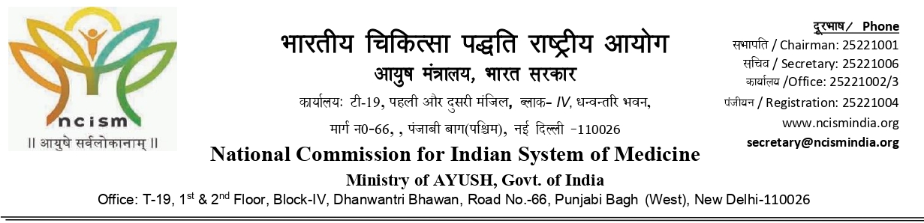
CLARIFICATION LETTER
Øekad/ Ref. No. –4-74/MARB/2025-Ay. (PB) fnukad/Dated: 06.08.2025

To,
The Principal
Punjab Institute of Ayurved, Hanumangarh Road,
Near Bye-pass Opposite BSF Campus,
Abohar- 152116, Punjab (Inst. ID- AYU0840)
Email: - 2024ayu0840@piaabohar.com

Subject:- Clarification in respect of shortcoming/defects observed in the assessment of Punjab Institute of Ayurved, Hanumangarh Road, Near Bye-pass Opposite BSF Campus, Abohar- 152116, Punjab (Inst. ID- AYU0840) for issuance of 2nd renewal of permission with intake capacity of 60 seats in UG (BAMS) course under section 29 of NCISM Act, 2020 and relevant regulations thereunder for the academic session 2026-27 -reg.

Sir/Madam,

This is with reference to the visitation of your college namely Punjab Institute of Ayurved, Hanumangarh Road, Near Bye-pass Opposite BSF Campus, Abohar- 152116, Punjab (Inst. ID- AYU0840) conducted on 20.03.2025 and 21.03.2025 on hybrid mode as a part of annual visitation by the visitation team of Medical Assessment and rating Board, NCISM to process the issuance of 2nd renewal of permission with intake capacity of 60 seats in UG (BAMS) course under section 29 of NCISM Act, 2020 and relevant regulations thereunder for the academic session 2026-27.

Further, the visitation report and all other related documents were assessed in terms of the enforced regulations, namely, “Minimum Standard of infrastructure and teaching & training facilities as specified in the NCISM (Minimum essential standards, assessment and rating for undergraduate Ayurveda colleges and attached teaching hospitals) Regulations, 2024”, and provisions under the NCISM Act, 2020 and relevant Regulations there under. On careful examination of the assessment report and as per the Visitor Observation following shortcomings/defects have been observed:-
- Mean of general and essential equipment’s/instruments availability is 47.67%.
- COA for the academic year 2025-26 is not submitted.

Therefore, you are directed to submit the clarification on the aforementioned shortcoming/defects within 1 day for processing of the issuance of 2nd renewal of permission with intake capacity of 60 seats in UG (BAMS) course under section 29 of NCISM Act, 2020 and relevant regulations thereunder for the academic session 2025-26.

(B. L. Mehra)
Member, Medical Assessment and Rating Board for Indian System of Medicine
(NCISM)

Copy to: -

- The Chairperson, National Commission for Indian System of Medicine, T-19, 1st Floor, Block-IV, Dhanwantri Bhawan, Road No.66, Punjabi Bagh (West), New Delhi-110026.
- The President, Medical Assessment and Rating Board for Indian System of Medicine, National Commission for Indian System of Medicine, T-19, 1st Floor, Block-IV, Dhanwantri Bhawan, Road No.66, Punjabi Bagh (West), New Delhi-110026 for information .
- Guard file.

(B. L. Mehra)
Member, Medical Assessment and Rating Board for Indian System of Medicine
(NCISM)

